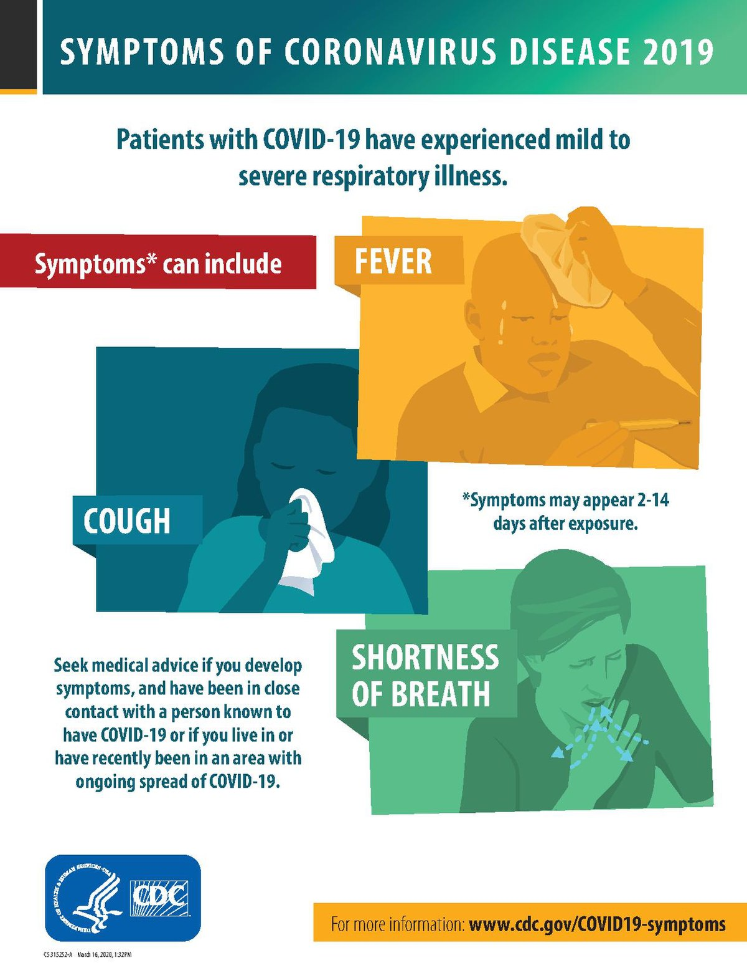

[This Photo](https://no.wikipedia.org/wiki/Fil:COVID19-symptoms.pdf) by Unknown Author is licensed under [CC BY-SA](https://creativecommons.org/licenses/by-sa/3.0/)